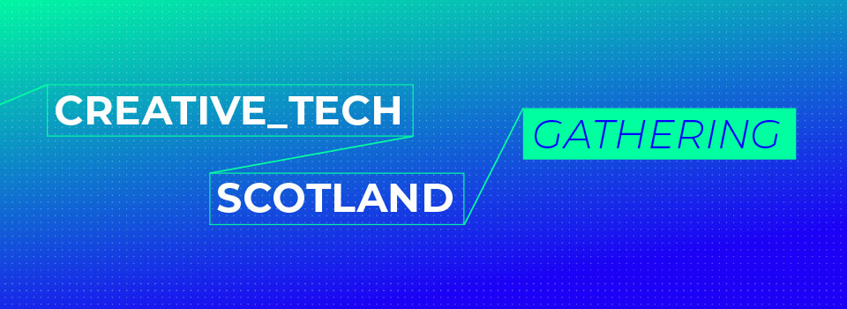

MusicTech Fest Labs 2022 – Attendance Support Funding

Equality, Diversity and Inclusion Monitoring Form

What data are we collecting and how will it be used?

The Equalities Monitoring Information will be held and used by CreativeTech Scotland Gathering team within the Edinburgh Futures Institute of The University of Edinburgh.

We are monitoring the diversity of the applications we receive to ensure we are reaching and
serving appropriate diverse audiences. This information also enables us to provide anonymised demographic reporting to funders and partners to ensure the programme is open and accountable in our commitment to diversity and equality.

The information we collect will not relate to our assessment of your application but is captured separately and for monitoring only. We include questions on age, gender, ethnicity, disability, and sexual orientation - all defined ‘protected characteristics’ in The Equality Act 2010.

As this information is sensitive and personal these questions are optional, but (where provided) this data does contribute to our ongoing review and improvement of our programme. We will always ensure that equality and diversity monitoring data is reported anonymously and with respect for your privacy.

Consent

In providing your completed response to these equality and diversity questions, you are giving explicit consent for us to use this data in our programme monitoring and reporting processes. The data is managed confidentially and will not have any bearing on your application. Your data will only be reported in anonymous aggregated form and will always be processed in accordance with the Data Protection Act 2018 and therefore also in accordance with the General Data Protection Regulation (GDPR).

If you prefer not to provide this information, please indicate this in the 'Prefer not to answer' box for the appropriate question(s).

Applicants can withdraw or modify their consent to collection and processing of personal information at any time by writing to; inbox@ctsg.scot

Equality, Diversity and Inclusion Monitoring Form

Please respond referring to the Key below.

- Please indicate your age range:

- What is your Nationality/Ethnicity:

- I identify my Gender as:

- Sexual orientation:

- Please indicate if you identify as having a disability:

Yes No Prefer Not to Say

Key;
- Age range:
18 – 24
25 – 35
35 – 44
45 – 54
55 – 64
65+
Prefer not to answer

- Nationality/Ethnicity:
White
Mixed/Multiple Ethnic Group
Asian or Asian British
Black/African/Caribbean/Black British
Other Ethnic Groups
Prefer not to answer

- Please self-identify

- Sexual Orientation;
Heterosexual
Bisexual
Gay
Lesbian
Other
Prefer not to answer

